**Web Programming Lab**

**IPS-1**

Name : Rohit Sinha

Registration Number: 22BCE5007

**Code(initial):-**

<html>

    <!--Header-->

    <head>

        <title>My Details</title>

    </head>

    <body bgcolor = "yellow">

        <center>

            <h1><font color = "red">Rohit Sinha</font></h1>

        </center>

        <center>

            <address>VIT Chennai Campus,Vandalur-Kelambakkam Road,Chennai - 600 127,Tamil Nadu, India</address>

        </center>

        <center>

            <p><br><a href="https://www.linkedin.com/in/rohit-sinha-a20107278/">Linkedin</a></p>

        </center>

        <hr color="black">

            <marquee><h3>+91 935958508</h3></marquee>

        <hr color="black">

        <center>

            <figure>

                <img src = "./assets/images/self-photo.png" width="100" height="100"></img>

                <p><figcaption>Rohit Sinha</figcaption></p>

            </figure>

        </center>

        <hr color="black">

        <section>

            <center>

                <h2>About Me!</h2>

            </center>

            <center>

                <p style="justify-content: center;">I'm a student passionate about coding, math, and rhythm<br> games. Coding fascinates me by unraveling puzzles, while<br> math challenges me intellectually. Rhythm games bring joy<br> through precision and synchronization. These interests<br> blend, shaping my diverse skill set and fostering a<br> multidimensional approach to learning.</p>

            </center>

            <center>

                <h3>Theoritical Interests:-</h3>

            </center>

            <center>

                <p>

                    1. <abbr title = "Artificial Intelligence">AI</abbr><br>

                    &nbsp;&nbsp;2. <abbr title = "Machine Learning">ML</abbr><br>

                    &nbsp;&nbsp;&nbsp;&nbsp;&nbsp;&nbsp;&nbsp;&nbsp;&nbsp;&nbsp;&nbsp;3. <abbr title = "Web Devolopment">Web Dev</abbr><br>

                    &nbsp;&nbsp;&nbsp;&nbsp;4. <abbr title = "Data Structures And Algorithms">DSA</abbr><br>

                    &nbsp;&nbsp;5. <abbr title = "Computer Networks">CN</abbr><br>

                </p>

            </center>

        </section>

        <hr color="black">

        <section>

            <details>

                <summary>1: <b>Rank 1</b> in CTF Cipher Hackathon</summary>

                Rohit Sinha showcased exceptional skills by securing the top rank in the competitive CTF Cipher Hackathon, demonstrating a keen understanding of cybersecurity and problem-solving abilities.

            </details>

            <details>

                <summary>2: <b>Rank 2</b> in Zero Day Hackathon</summary>

                My prowess in hacking and innovative problem-solving led to an impressive second-place finish in the challenging Zero Day Hackathon, highlighting my technical proficiency.

            </details>

            <details>

                <summary>3: <b>Rank 5</b> in Google House of Developers Hackathon</summary>

                Securing the fifth position in the prestigious Google House of Developers Hackathon showcases my ability to thrive in high-pressure coding competitions, highlighting my adaptability and skill.

            </details>

            <details>

                <summary>4: OSU! India Rankings <b>#80-stable #75-lazer</b></summary>

                My dedication to rhythm gaming is evident in my impressive rankings, standing at #84 in OSU! Lazer and #78 in OSU! India, displaying precision and synchronization in this domain.

            </details>

        </section>

<hr color="black">

    </body>

</html>

**Output:-**

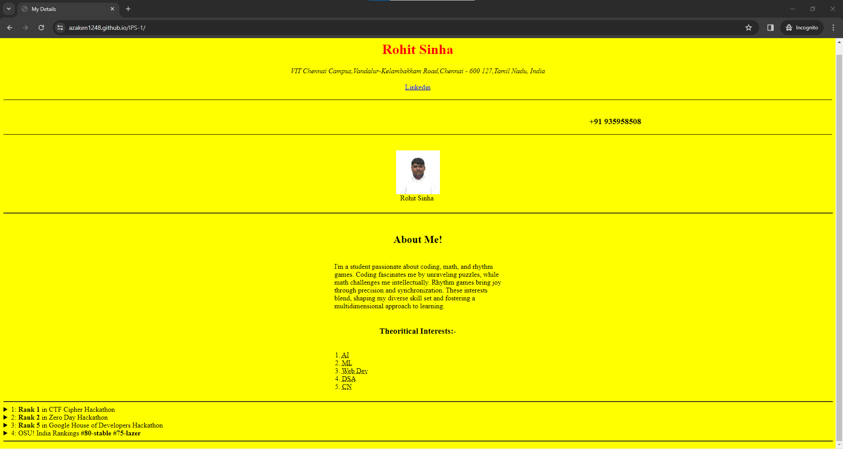

**Pages Link:-**

<https://azaken1248.github.io/IPS-1/>